* 1. **Purpose:** This tool helps to make it easier for the team to find discrepancies within the plant instead of the usual process that takes too long to execute, with this tool you just need to click each button to do their purpose and within a minute you will be able to see the discrepancies for the week.

This tool also has dashboard wherein you can see the total discrepancies reported, monthly discrepancies of the plant, top 5 plants with the most number of discrepancies, and MES plant support regional map.

Additionally, we added another step for reporting purposes which is saving the alerts on the shared folder for every alert sent to the team from Outlook.

**1.2 Members:** MES Manila Team and SAP-MES EMEA Team

**1.3 Old Process Algorithm**

1. Open the alert sent from Outlook, then Select All, Copy, and Paste it on the blank worksheet.

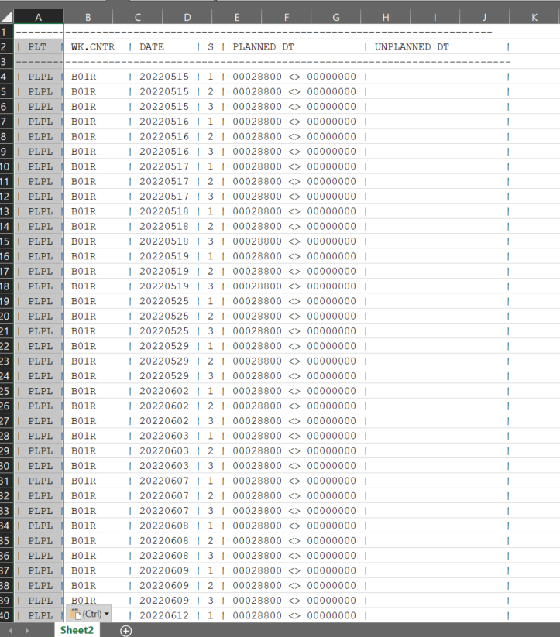

1. We will have to delimit the data by going to Data Tab > Data Tools Group > Text to Columns > Delimited > Next > Select Other then put “|” as delimiter > Next > General > Finish.

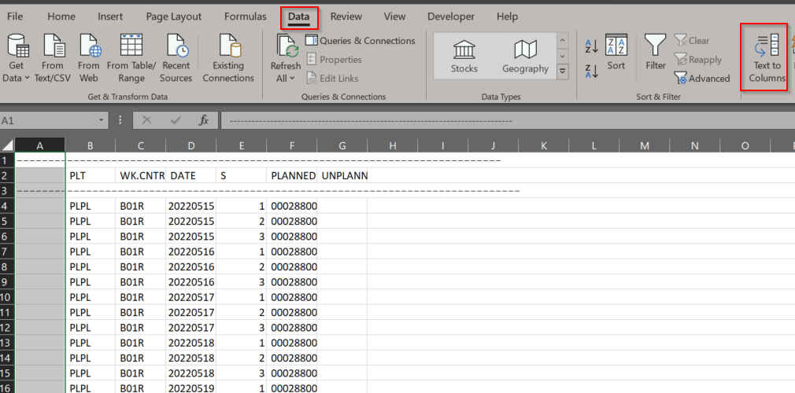

1. Remove the unnecessary columns, only PLT and DATE column is to be extracted.

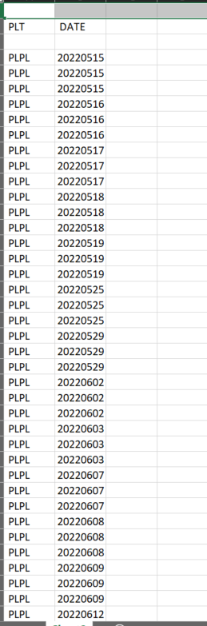

1. Select the two columns and click the Remove Duplicates button by going to Data Tab > Data Tools Group > Remove Duplicates > Check the “My data has headers” box > OK.

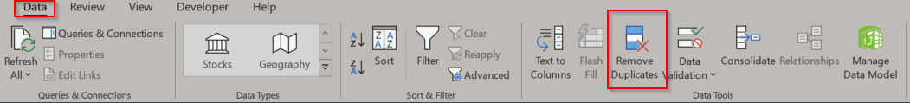

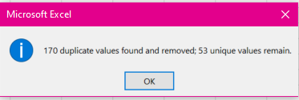

1. Select the DATE column and click on the Sort button by going to Data Tab > Sort & Filter Group > Sort Smallest to Largest > Continue with the Current Selection > Click Sort button.

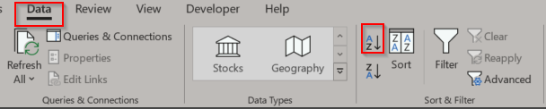

1. Add Headers on the cells C1, D1, E1 with the titles “**Recalc OEE”**, “**Upload OEE”,** and **“Upload Downtimes”**.

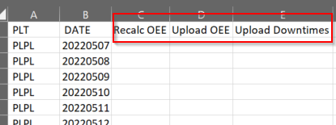

1. Start processing the dates on each job on MII Scheduler.
2. For **Recalc OEE**:
   1. Count the number of days from start to end date and add 1 day for the assurance and this will be the value of the **days** parameter.
   2. Get the end date from the worksheet with the format **YYYY.MM.DD** as required on MII. This will be the value of the **endDate** parameter.
   3. Once done, select the cells from the Recalc OEE column, and mark the cells as green.

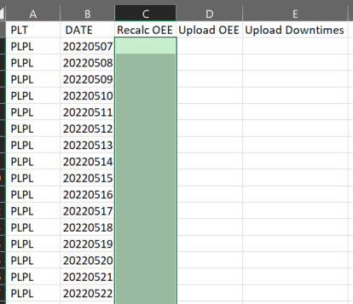

1. For **Upload OEE**:
   1. The value of **Days** parameter is 0 as default value.
   2. Get the end date from the work sheet with the format **YYYYMMDD** as required on MII. This will be the value of the **endDate** parameter.
   3. Get the start date from the work sheet with the format **YYYYMMDD** as required on MII. This will be the value of the **startDate** parameter.
   4. Once done, select the cells from the Upload OEE column, and mark the cells as green.

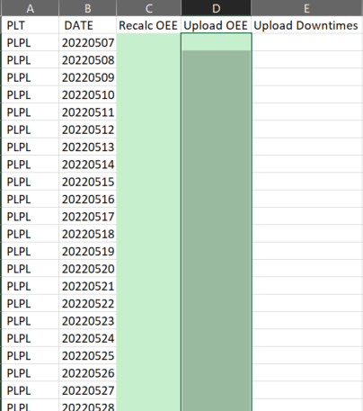

1. For **Upload Downtimes:**
   1. The value of **daysBack** parameter is 0 as default value.
   2. If multiple days, count the data on the DATE column from 1-8 then this will be the range for 1st range and so on. Then get the start date from the range and this will be the value for **DateFrom** with the format **YYYYMMDD**. Lastly, get the end date from the range and this will be the value for **DateTo** with the format **YYYYMMDD**.
   3. Once done, select the cells from the Upload Downtimes column, and mark the cells as green.

***Note: To visualize, Blue is for 1st range; Orange is for 2nd range; Gold is for 3rd range

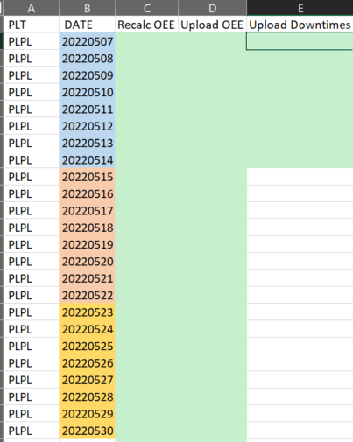

1. The work is complete.
   1. **New Process Algorithm**
2. Save the alerts sent to Outlook on a shared folder, then rename the saved message to this format: **YYYY-MM-DD**-Downtimes discrepancy report.msg

Note: The date is when you received the alert from Outlook.

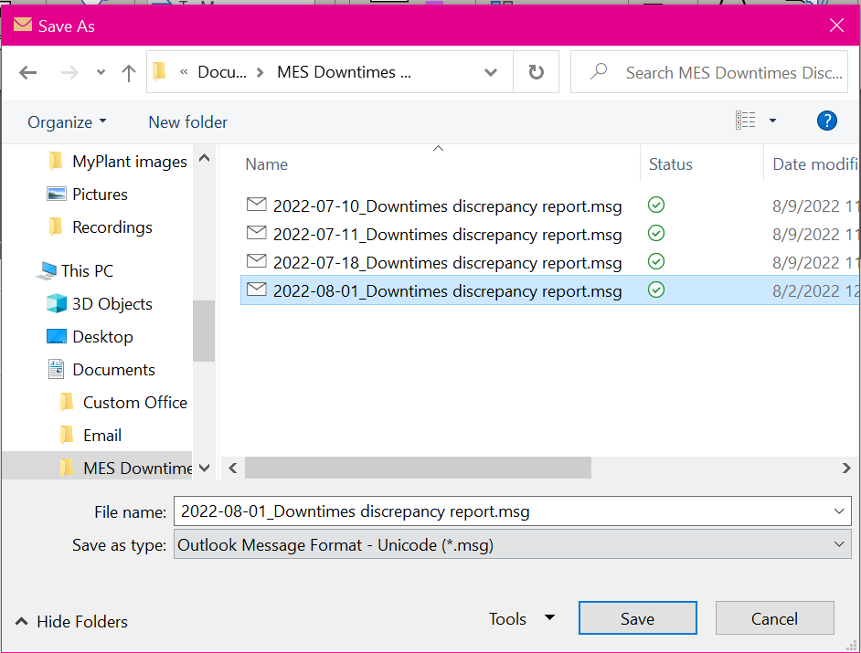

1. Open the MESDiscrepancyReportTool.xlsm file.
2. Go to **Discrepancy Report** tab if there is a new discrepancy in the downtimes for the week.
3. Click the **“Open Report”** button to show the saved alerts on that week, double-click the message, then Select All (Ctrl + A), and Copy (Ctrl + C) and Paste (Ctrl + V) it on cell A2.

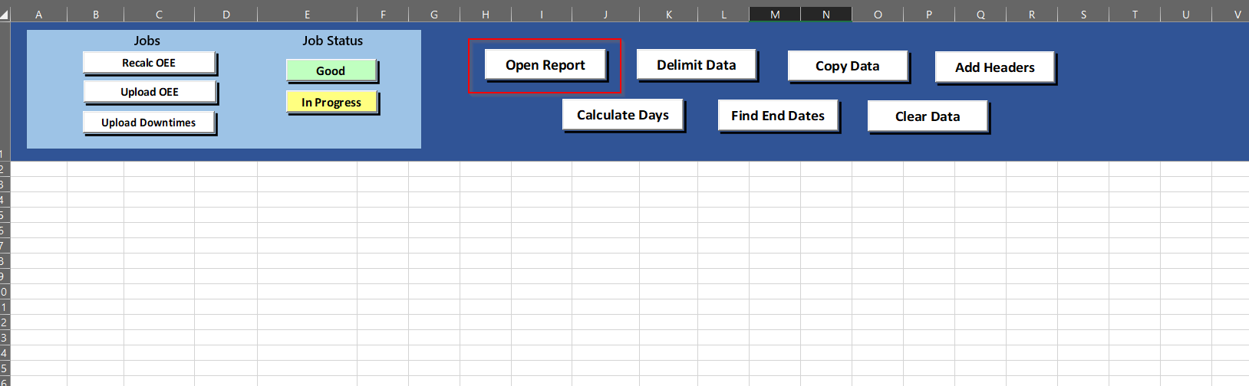

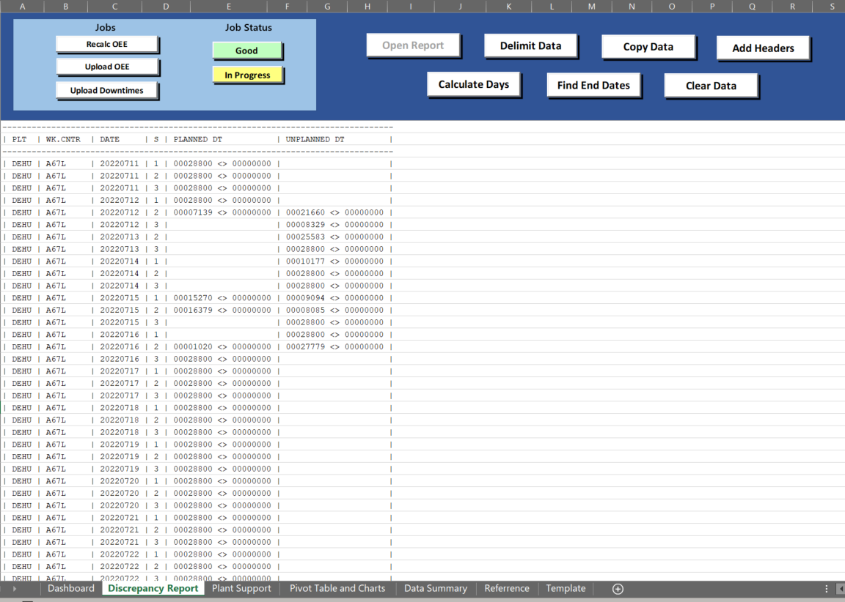

1. After copying data from email, Click the **“Delimit Data”** button and this will perform the steps indicated below; Once done, it will pop a message saying, **“Data Delimited”**
   1. Delimits the pasted data on the worksheet from the saved alert.
   2. Deletes the unnecessary columns, where PLT and DATE column is only needed.
   3. Removes the duplicate dates.
   4. Sorts the dates from oldest to recent ones.

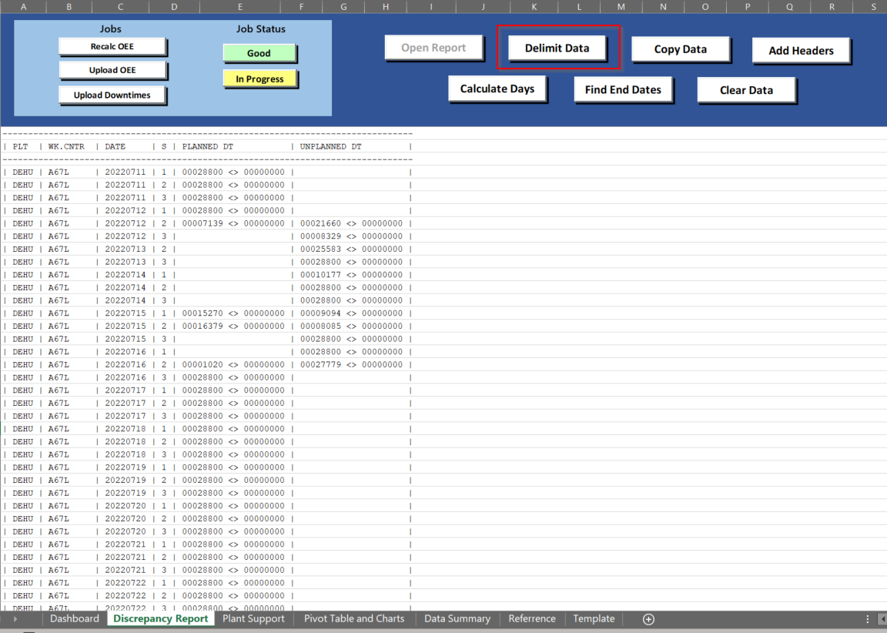

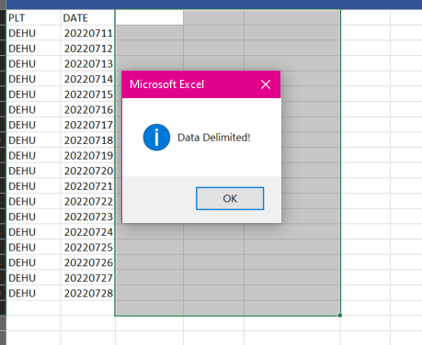

1. For **Report and Dashboard purposes**, click the **“Copy Data”** button and all the data on the **Discrepancy Report** worksheet will be copied and pasted to **Data Summary** worksheet. Once done, it will pop a message saying, **“Data Copied!”**.

***Note: You can only do this step once since the button will automatically disable to avoid pasting the duplicate records.

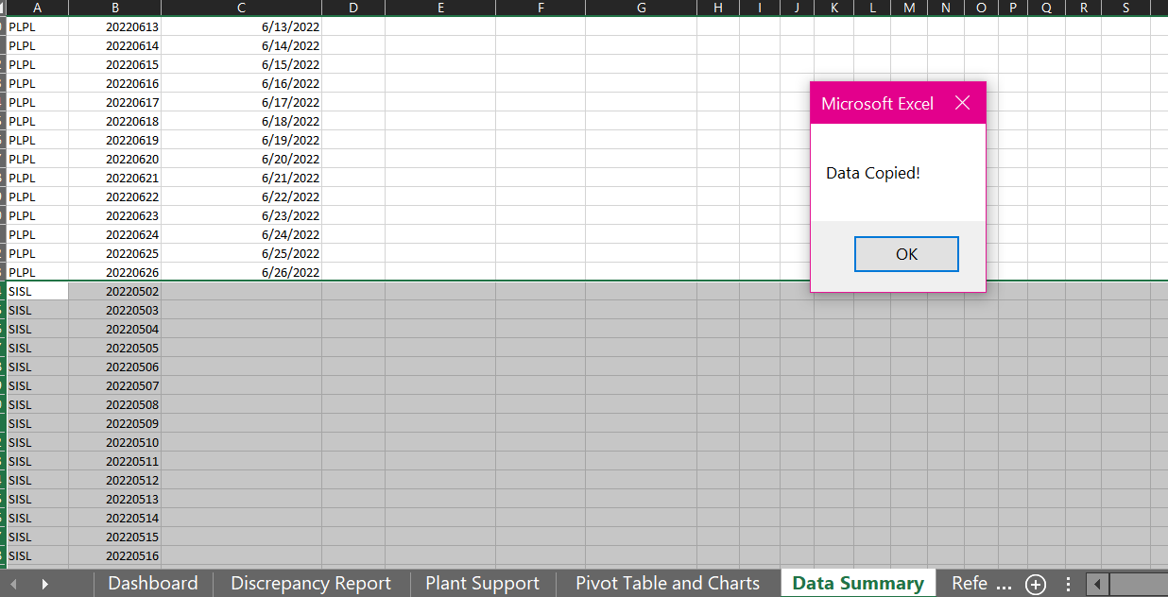

1. Click the **“Convert to Date”** button as this will convert the string **DATE** column to date in MM/DD/YYYY format on **Converted Date** column. You will get another pop up saying, **“Date Converted!”**.

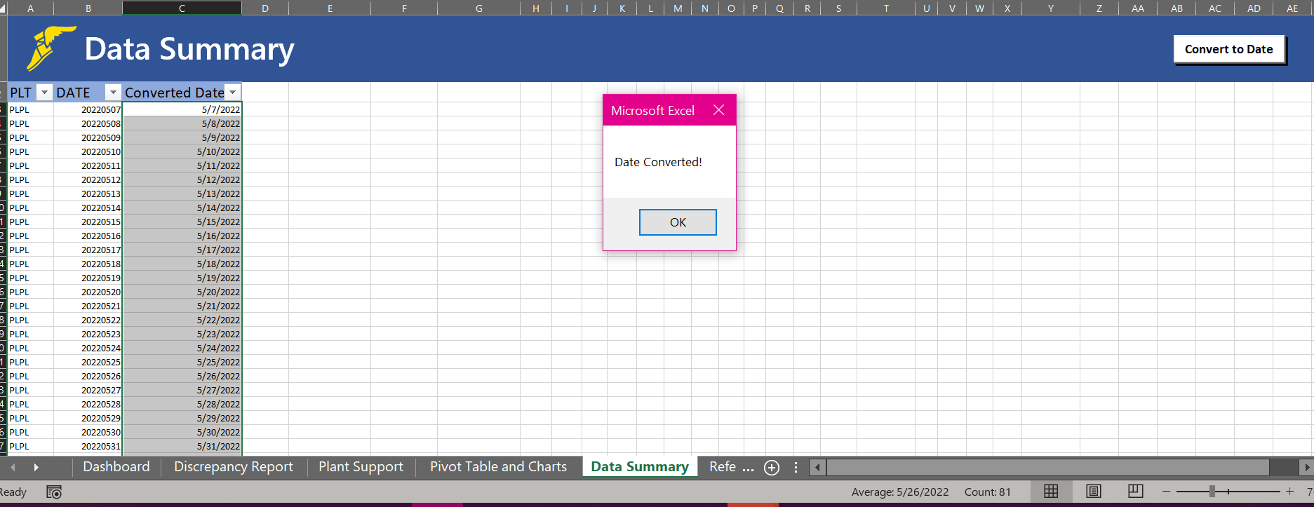

1. Go back to **Discrepancy Report** Worksheet and click the **“Add Headers”** button and it will insert column headers on cells C2, D2, and E2 with the titles **“Recalc OEE”, “Upload OEE”,** and **“Upload Downtimes”.** You will get another pop up saying, **“Headers Added!”**.

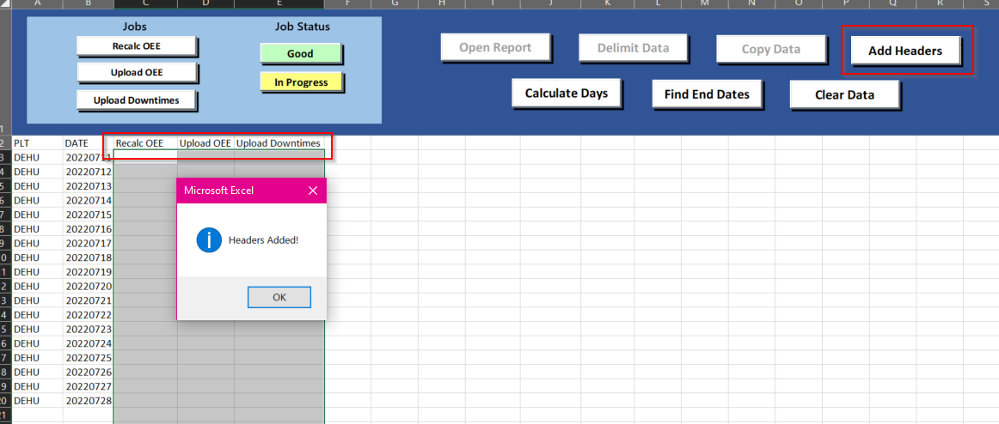

1. Start getting the discrepancies by starting on the **Recalc OEE** job by clicking the **“Recalc OEE”** button, and a popup dialog box will appear with the data seen below:

**Where:**

* **days** is the count of number of days from start to end date + 1 day (for assurance).
* **endDate** is the end date from the worksheet converted to **YYYY.MM.DD** format as required on MII.
  1. Once done, click the “Mark as Complete” button and the Recalc OEE column will be marked as green.

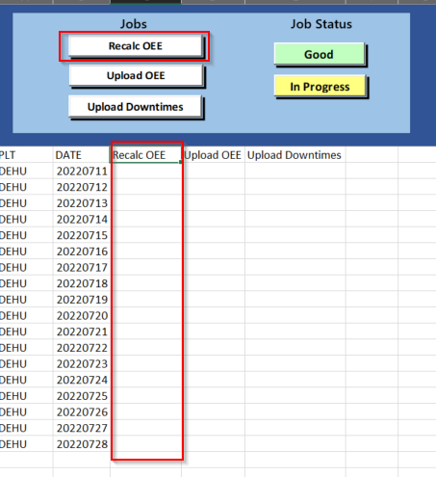

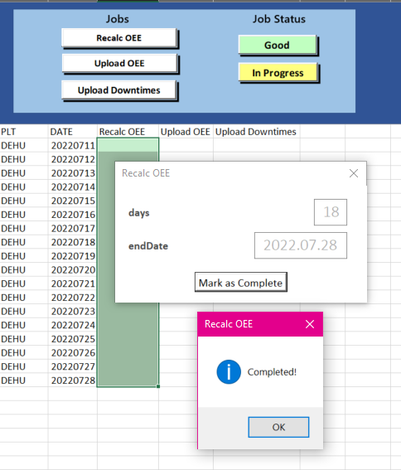

Note: The labels you see on the dialog box is the same as MII scheduler, input the data on the MII Transaction Scheduler tab with the following data:

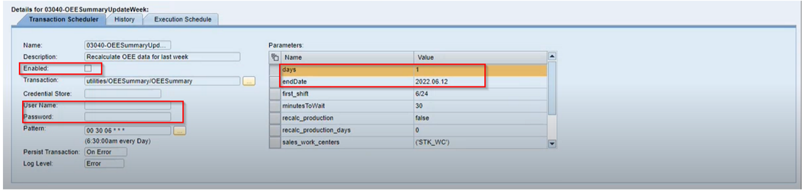

1. Next job is the **Upload OEE**, click on the **“Upload OEE”** button and a popup dialog box will appear with the data seen below:

**Where:**

* **Days** is 0 (set as default).
* **endDate** is the end date from the worksheet converted to **YYYYMMDD** format.
* **startDate** is the start date from the worksheet converted to **YYYYMMDD** format.

10.1Once done, click the “Mark as Complete” button and the Upload OEE will be marked as green.

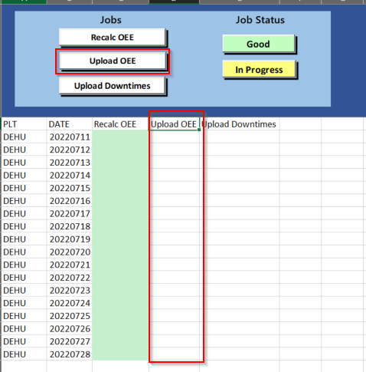

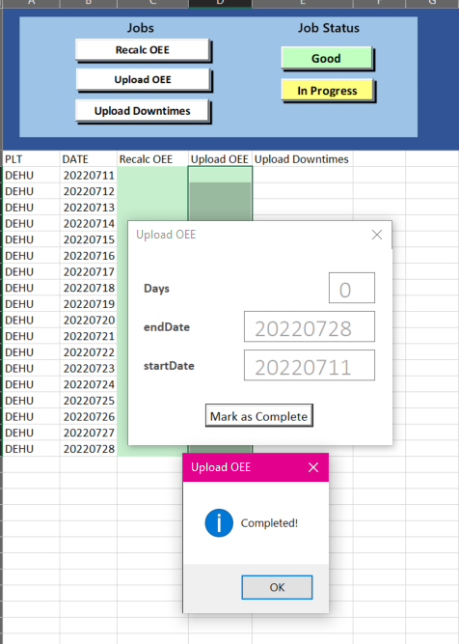

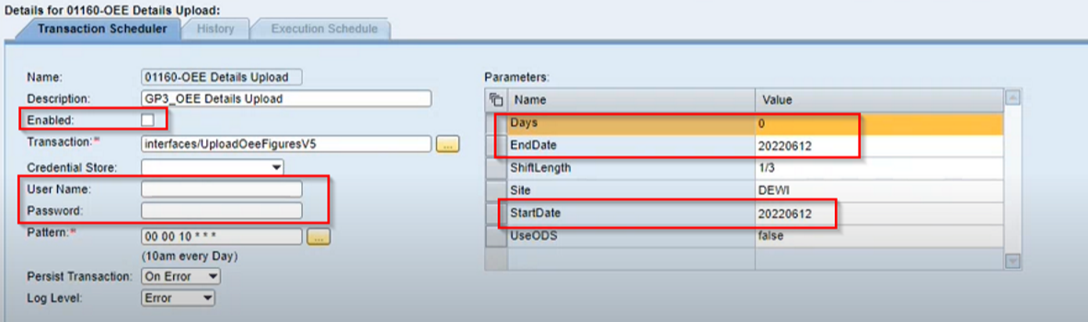

1. Last job to get is the **Upload Downtimes**, In this job the total number of selected dates must be 8. To see the 8th selected date, click the “**Find End Dates”** button and this will highlight the 8th selected date from the DATE column.

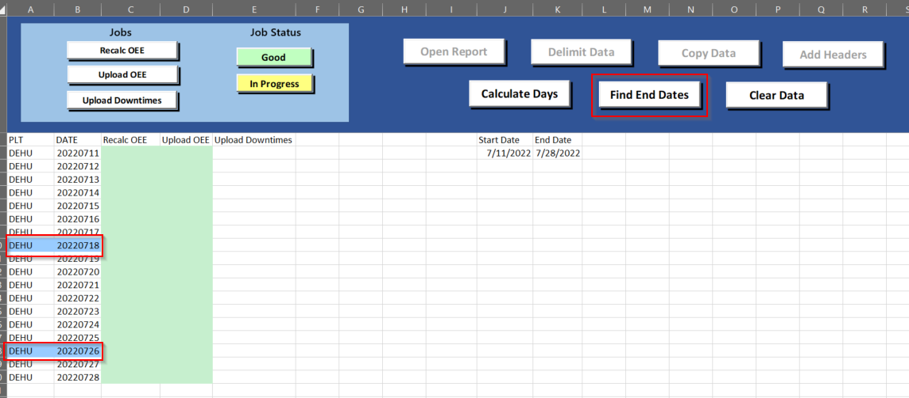

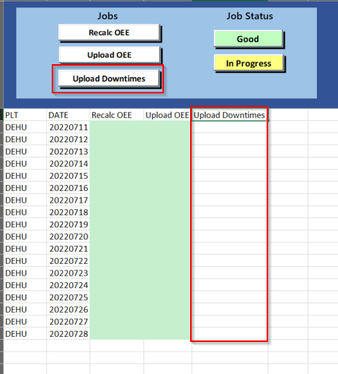

* 1. Next, click on the “**Upload Downtimes”** button and a popup dialog box will appear. Choose the range of dates by dragging the dates downwards or by pressing Shift, an indicator will be shown how many dates were selected. Click the “**>>**” button and this will transfer the selected dates to another listbox, press Shift again, then click “**Find Range**” button. Another popup box will appear.

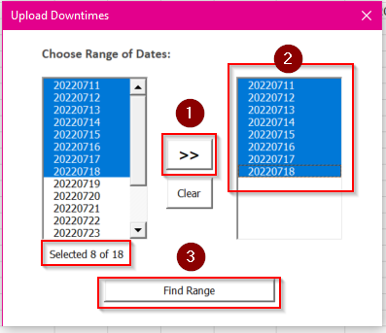

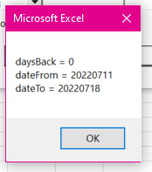

**Where:**

* **daysBack** is 0 (set as default).
* **DateFrom** is the start date from the worksheet converted to **YYYYMMDD** format.
* **DateTo** is the end date from the worksheet converted to **YYYYMMDD** format.
  1. After completing each range of dates, you can now mark it as Good if it is processed on MII, In-Progress if the dates are still processing on MII.

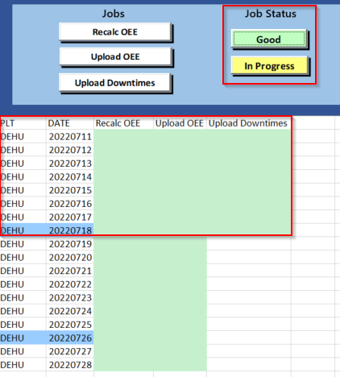

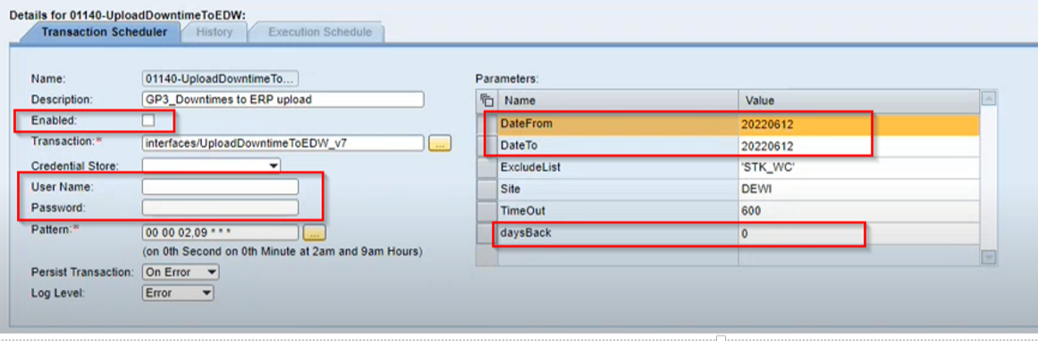

1. The work is complete.

* 1. **Timeline**



* 1. **Change History**

|  |  |  |
| --- | --- | --- |
| **Date** | **Description** | **Author / Reviser** |
| 08/10/2022 | Initial Documentation | Yza Brucelas |
| 09/22/2022 | Final Documentation | Yza Brucelas |
|  |  |  |